22nd March 2022
Renishaw’s next generation radio transmission probing system delivers a data-rich future and an increase in battery life of up to 400%
Global engineering technologies company, Renishaw, will showcase its latest radio transmission probing system for machine tools at MACH 2022. The next generation system will be one of many smart factory process control solutions demonstrated by Renishaw, which are proven to help machine shops across many industries transform their production capabilities.
The new system comprises an ultra-compact RMI-QE radio interface with an updated communication protocol, as well as major updates to the complete range of market-leading radio transmission probes. The new enhancements deliver significantly improved battery life, simplified set up, and remote diagnostics to all radio probes.

A connected interface for a digital future
Situated inside the machining environment, the RMI-QE interface features an updated communication protocol and is future-proofed to support a new generation of Renishaw sensors and smart devices.
Robust and reliable in busy radio environments, the RMI-QE utilises an updated version of Renishaw’s industry proven 2.4 GHz frequency hopping spread spectrum (FHSS) radio transmission technology and remains compliant with radio regulations worldwide. The system is suitable for applications that cannot guarantee line-of-sight between probe and receiver – such as in 5-axis, multi-tasking and mill-turn machines. It also allows up to four separate tool setting probes or spindle probes to be operated on the same CNC machine – ideal for machining centres with rotary tables or twin pallets.
The ultra-compact design enables a multitude of flexible mounting option. As well as operating with the RMI-QE interface, the updated radio transmission probes provide full backwards compatibility with the legacy RMI-Q interfaces

User friendly probing
Users have always been able to manually configure Renishaw radio probe settings to suit the operating conditions of their machines – particularly useful for high vibration and high-speed applications. However, the process is now significantly easier. In an industry first, the Opti-Logic™ technique, accessed via the new Probe Setup app, enables probe settings to be configured using a smartphone. Selectable options displayed on the smartphone screen are transferred to the probe through a two-way communication. Not only does this significantly simplify the configuration process but also makes remote diagnostics possible via common applications, including email, iMessage®, WhatsApp, LINE and WeChat.

Environmentally friendly probing
Updates to the probes’ electronics and radio transmission deliver an increase in battery life of up to 400%, which when used with the RMI-QE, offers an industry-leading battery life of up to 5 years based on typical usage. But, as James Hartley, Applications and Marketing Manager for Renishaw’s Machine Tool Products Division explains, this design change is more than just battery life improvements, “While we are immensely proud of the technological advancements this next generation system delivers, we are equally proud of our on-going project to increase the environmental efficiency of our products. With the battery life improvements demonstrated here and with recent improvements to our OMP40-2 and OSP60 optical transmission probes, we are committed to minimising the environmental impact of our products by reducing the consumables associated with them.”

Your partner for innovative manufacturing
Renishaw’s next generation radio transmission probing system enables reliable, automated on-machine tool setting, tool breakage detection, part set up and part verification capability. Integrating these control methods into your manufacturing processes can provide the data you need to significantly improve productivity, machine utilisation and reduce reliance on operators and human intervention.

For more information, visit us at MACH in Birmingham, UK (4th – 8th April 2022, stand H19-300)

iMessage® is a trademark of Apple Inc.

-ENDS-

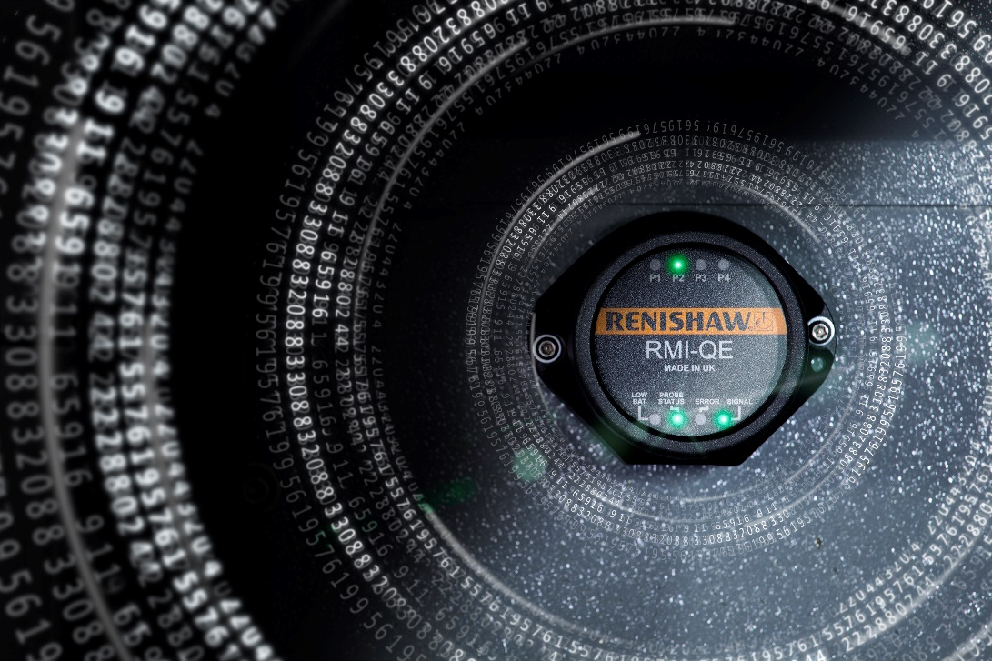
RMI-QE radio interface
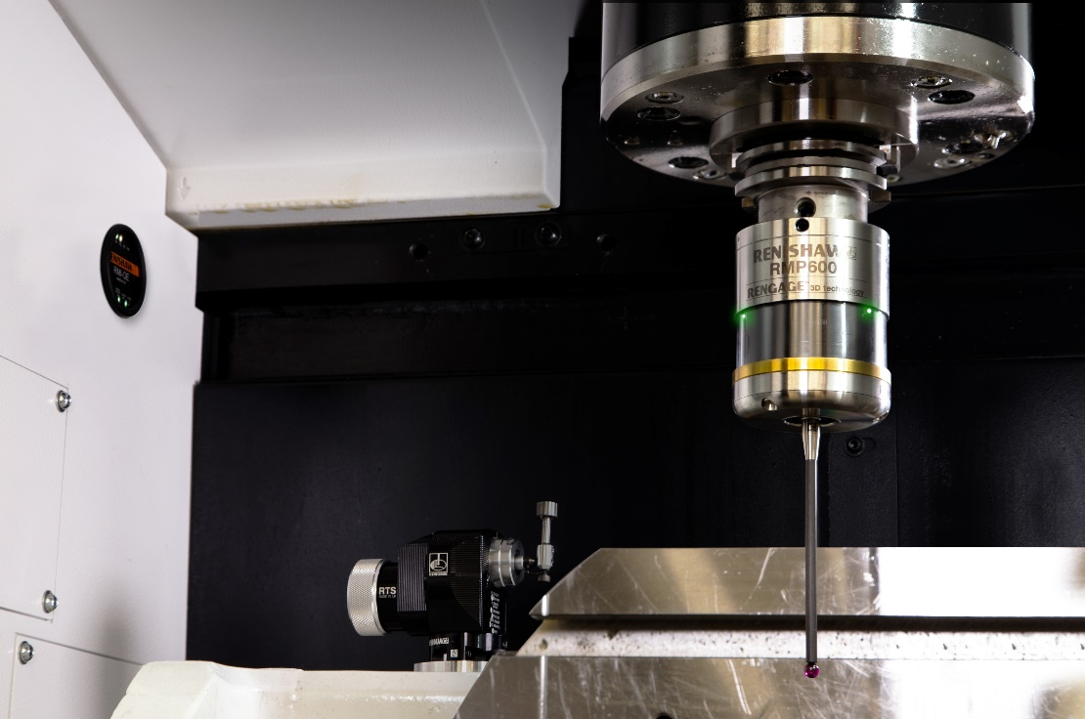

RMP60 spindle probe, RTS tool setter and RMI-QE radio interface in machine

Opti-Logic™ symbol on RMP60 spindle probe

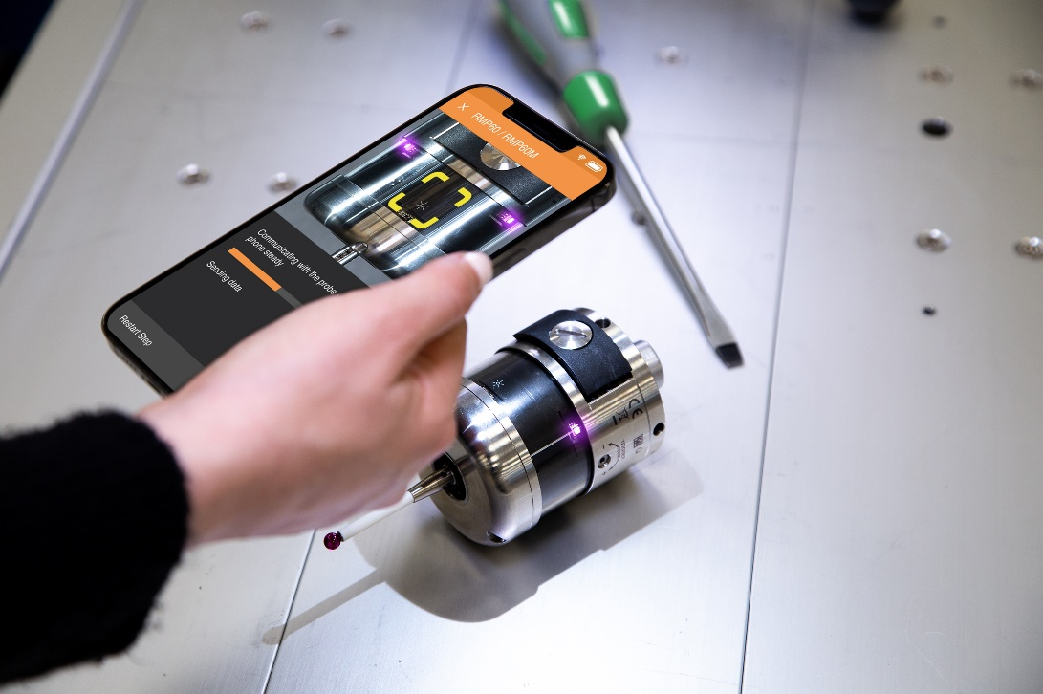
Probe configuration using the Probe Setup app

