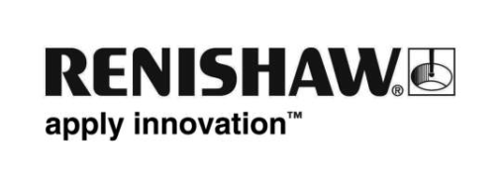
September 2019 – for immediate release Further information: Chris Pockett, +44 1453 524133

MM award for Renishaw’s XK10 alignment laser system
Renishaw’s new XK10 alignment laser system has won the MM Award for ‘Quality Assurance’ at the EMO 2019 exhibition held in Hannover, Germany. The awards were presented by the principal German trade magazine MM Maschinenmarkt during the EMO exhibition which is the world’s leading trade fair for the metalworking industry.
The MM award for XK10 was presented on 23rd September 2019 to representatives from Renishaw’s GmbH subsidiary; Rainer Krug, Sales and Business Development Director and Joerg Reichle, Sales Engineer. This award reinforces the success of XK10, having recently been presented the Gold Medal at the MTP Fair, Poland.
The XK10 alignment laser system has been developed for use during the build and alignment of machine tools, replacing the need for artefacts. It can be used on linear rails to ensure that they are straight, square, flat, parallel and level, as well as to assess spindle direction and coaxiality of rotary machines. These factors can be measured and aligned with the XK10 during build, using the system’s live display. The XK10 is also a powerful tool for diagnosing the source of errors following a collision or as part of regular maintenance.
For further information about XK10 visit https://www.renishaw.com/xk10

Ends

