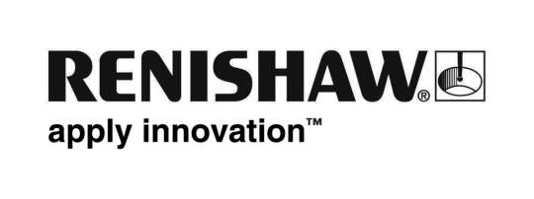
July 2019 Enquiries: Chris Pockett, Head of Communications (+44 1453 524133)

Additive manufacturing cuts lead times for Knust-Godwin
Global engineering technologies company, Renishaw, has supplied four RenAM 500Q metal additive manufacturing machines to Knust-Godwin, a precision machining company located in Katy, Texas, USA. These high-productivity systems, designed for serialised industrial manufacturing, have enabled Knust-Godwin to drastically reduce lead times for their customers.

Knust-Godwin has been in business for over 50 years and has a long history of machining large, complex parts for oilfield instrumentation. The company first introduced additive manufacturing as a new technology to help its customers develop new tooling designs and improve the efficiency and productivity of tools in the oil and gas industry. The company has now chosen to expand its additive manufacturing (AM) capacity to handle serial production, purchasing four RenAM 500Q machines.

AM technology brings a number of benefits to the oil and gas industry, such as by producing components for down hole measurement while drilling and logging, which offer more efficient flow. This increases efficiency of flow rates and leads to longer tool life. The company is also benefitting from less waste, shorter lead times and fewer post processing steps ― products that typically took six to twelve steps to complete can now be completed in two to three.

“Additive manufacturing started as a prototyping technology, but it is now a serialised production process,” explained Mike Corliss, VP of Technology at Knust-Godwin. “Because we are designing components specifically for AM, we have been able to reduce customers’ lead times. A project which previously required a 24 month wait from concept to commercialisation can now be reduced to eight months. The cyclical nature of the oil and gas industry means that providing parts quickly is extremely important.”

“Knust-Godwin has not only benefitted from the huge productivity gains of the machines, but also from tremendous support from Renishaw,” continued Corliss. “We see AM playing a large role in our company’s future and we are expecting to see a 40 per cent compound growth year-on-year in the oil and gas industry, and 20 per cent compound growth in aerospace. We are even looking at purchasing additional RenAM 500Q machines for different metal alloys.”

“The RenAM 500Q offers productivity and efficiency gains over traditional single laser machines,” added Robin Weston, Marketing Manager of Renishaw’s Additive Manufacturing Product Division. “The benefits offered by AM mean that more and more industries are turning to the technology as a way of producing high-quality, efficient parts.”

The RenAM 500Q offers four lasers in the most commonly used platform size, increasing productivity by up to four times, with no compromise on quality. To find out more about AM for serialised production, visit www.renishaw.com/additive.

Ends 439 words
Notes to editors
UK-based Renishaw is a world leading engineering technologies company, supplying products used for applications as diverse as jet engine and wind turbine manufacture, through to dentistry and brain surgery. It has over 4,500 employees located in the 36 countries where it has wholly owned subsidiary operations.

For the year ended June 2018 Renishaw recorded sales of £611.5 million of which 95% was due to exports. The company’s largest markets are China, the USA, Germany and Japan.

Throughout its history Renishaw has made a significant commitment to research and development, with historically between 13 and 18% of annual sales invested in R&D and engineering. The majority of this R&D and manufacturing of the company’s products is carried out in the UK.

The Company’s success has been recognised with numerous international awards, including eighteen Queen’s Awards recognising achievements in technology, export and innovation.

Further information at www.renishaw.com

